Name:Rakib Rary,Shailesh Ghale, Djiedjom Gbonkou, Hang Lin

1. What is your business?

The business involves marketing 3D printing services to customers who desire high-quality designs and prices. From keychains, phone cases, and figurines we offer a wide variety of products. To add on we also create or print custom designs.

1. Business ethos: Our business ethos is to provide high-quality and affordable 3D printing services to our customers while maintaining excellent customer service and developing a creative and collaborative environment.
2. What do you produce/make/offer/sell?

We utilize high-quality, fast-producing 3D printers and resin printers for various purposes. We use 3d printers for low-quality design prints and resin printers for high-quality designs. Our webpage is utilized similarly to a catalog for customers to browse through to get ideas and possibly come up with their own ideas for us to create.

1. Who is your target audience?

Our target audience can be hobbyists, small businesses, companies, and practically anyone who needs an affordable option or quality.

1. What are the key motivations of why you expect people to visit your website and how you will attract and motivate people therein?

There are several motivations such as favorite characters, holiday antiques, or even needing a specific moving part. We will attract people through advertising, but also educate them as well in the process.

1. Do they want general information/research (such as background on a topic/company), or are they after something specific (such as a particular fact or information on a product)?

Customers may look for information on what 3D printing technology is and the various materials and types there are for it. They may also question the products listed and any concerns associated with them. Some people may already know about the technology; they might have questions about how to print it for themselves or ask for specifics to design for more complexity.

1. Are they already familiar with the service or product that you offer or do they need to be introduced to it?

Some people will need to be introduced to it, others not so much. 3D printing is a technology that has been around for some time, and there are lots of educational videos that can simply explain it.

1. are they looking for time-sensitive information, such as the latest news or updates on a particular topic?

There is not much time-sensitive information; however, there are trends in designs, holiday designs, or even personal designs that people may need. Furthermore, if we changed or added new technology to our 3D printing business, our customers would be interested as well.

1. do they want to discover information about a specific product or service to help them decide whether to buy it or not?

Some customers may want to know the specific for example the weight and size of the 3d print, how durable can it be, and what types of models can we create. There will be various models and descriptions on our websites for customers to better understand the value behind our products.

1. do they need to contact you? If so, can they visit in person (which might require opening hours and a map)? Or might they need email or telephone contact details?

Some customers will need to contact us for various issues for example if a 3d print breaks while in the shipment process or if they want to reach out and leave a good review. There will be a contact section form on the website along with an email and phone number as well.

1. will visitors be familiar with your subject area/brand or do you need to introduce yourself?

Many people are still not familiar with 3d printing technology. There will be an introduction part of the site in the about me section that gives a summary of our business.

1. will they be familiar with the product/service/information you are covering or do they need background information on it?

Customers will need background information as it was already mentioned many people do not know what 3d printing technology is. We will use links and lists on the website to help customers better grasp these concepts. We will also state a refund policy as well to meet the customer's needs.

1. what are the most important features of what you are offering?
2. Customization: Customers are able to customize already existing or new 3d prints.
3. Speed: Our printers are fast production for those who have a deadline
4. Price: Depending on the material, time cost, and resources we offer the cheapest affordable option.
5. Customer service: We have fast responsive customer service
6. what is special about what you offer that differentiates you from other sites that offer something similar?
7. Quality and accuracy: We use high-quality 3d printers
8. Customer service: Our customer service is very knowledgeable about 3d printers to help support customers.
9. Speed: While printing at fast speeds we maintain the quality of our prints.
10. Competitive Pricing
11. once people have achieved the goal that sent them to your site, are there common questions people ask about this subject area
12. How does 3D printing technology work, and what are its applications in different industries?
13. What are the different types of 3D printers and printing materials available, and which ones are best suited for specific projects or applications?
14. How can customers ensure that their 3D prints are of high quality and accuracy, and what factors can impact the final result?
15. What types of design software are compatible?
16. What are the costs?

Your white paper should explain how you implemented concepts in the visual hierarchy, grouping, and similarity in your design

1. Home- Gallery section of the website.

2. About- Gives an overall summary of our business.

3. Services- Gives the prices, 3d print links, and educational resources.

4. Contact- A contact form customers use.

Your white paper should take another website (that already exists on the web) and analyze it based on the above, creating a wireframe for it as well.

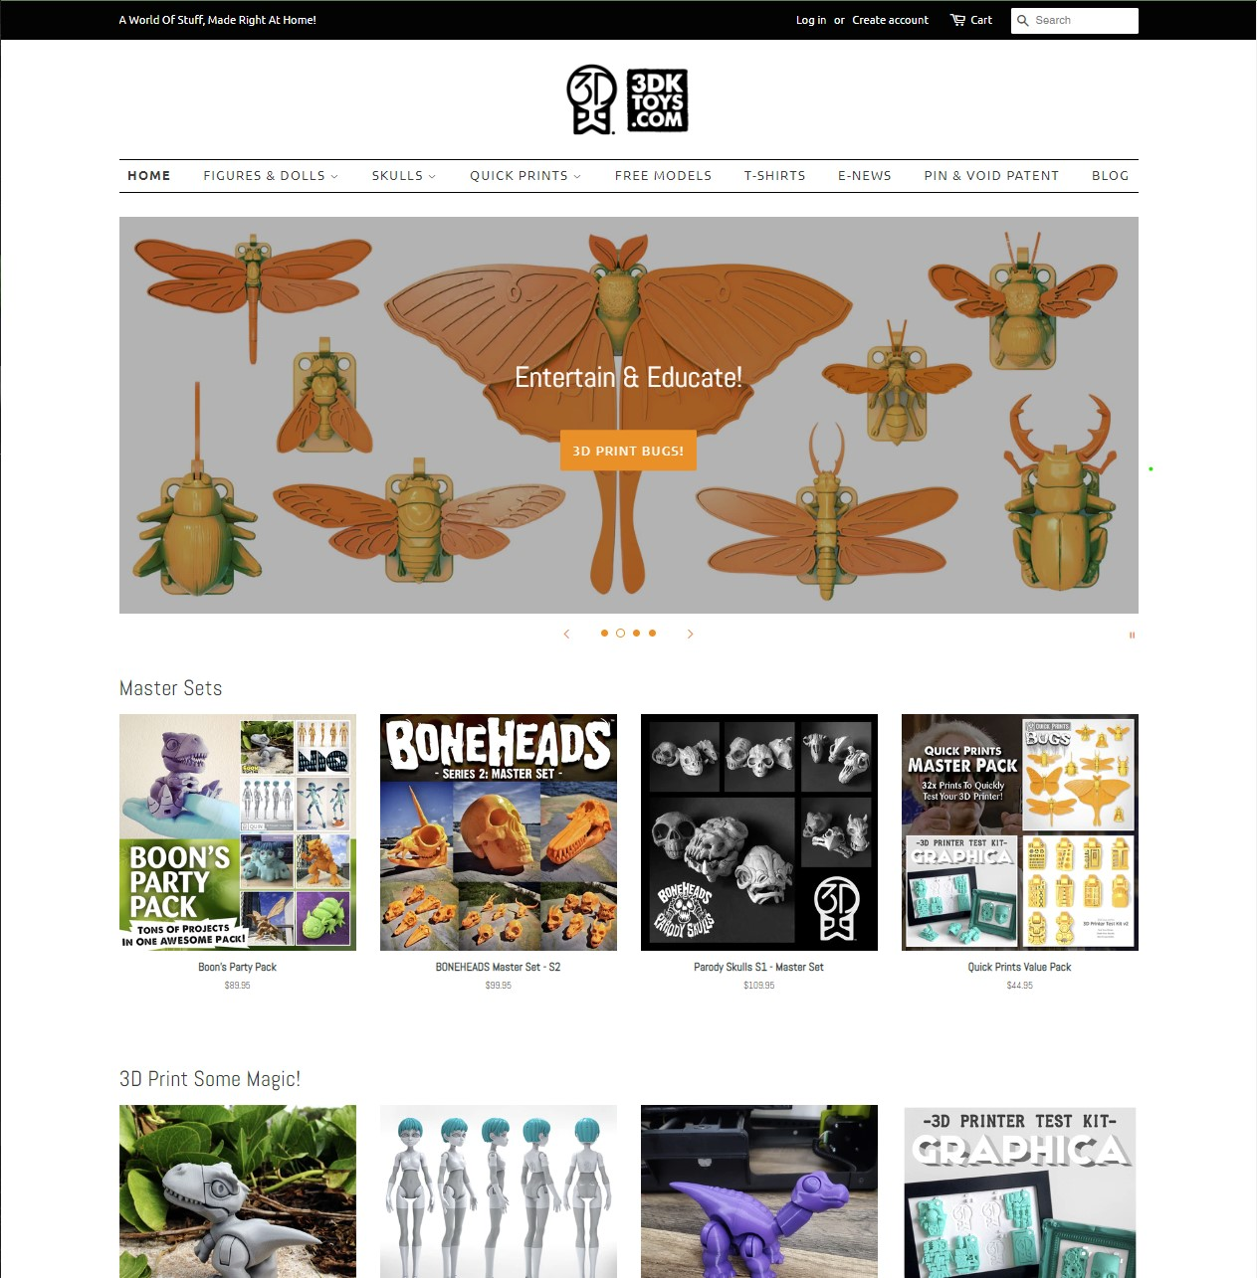

* You should have one HTML, CSS, and JS file for each page of your website (so altogether there will be 12 files). You should upload the files to github and submit a link. On Blackboard, you should be uploading the following:
  1. your white paper
  2. your gray paper
  3. your wireframes
  4. a screenshot of each of your websites (uploaded as a PDF)
  5. a link to your github where each of the HTML, CSS, and JS files are
  6. a video of you showing your website in action, and explaining the highlights of your code. You should mention two or three issues that you had trouble with and how you figured them out.

TO DO:

-Java Script (gallery photo/ search function)

-Graypaper:You must create a gray paper that explains the HTML, CSS, and JS that you did. It should outline at least 30 different points, showing the code and explaining what it does (Djiedjom Gbonkou)

-udemy course 5 examples- (Hang Lin and Shailesh Ghale)

4 udemy courses are done:

-Theme clock, hidden search widget, auto text effect, FAQ collapse- Hang Lin

Still need 1 more

Options: blurry loading, form wave animation, double heart click…

-a video of you showing your website in action

-Create a github link.